To set up a new custom MQTT device in calaos installer do the following: Add Item -> Mqtt and select device, in this example we have selected temperature Sensor.
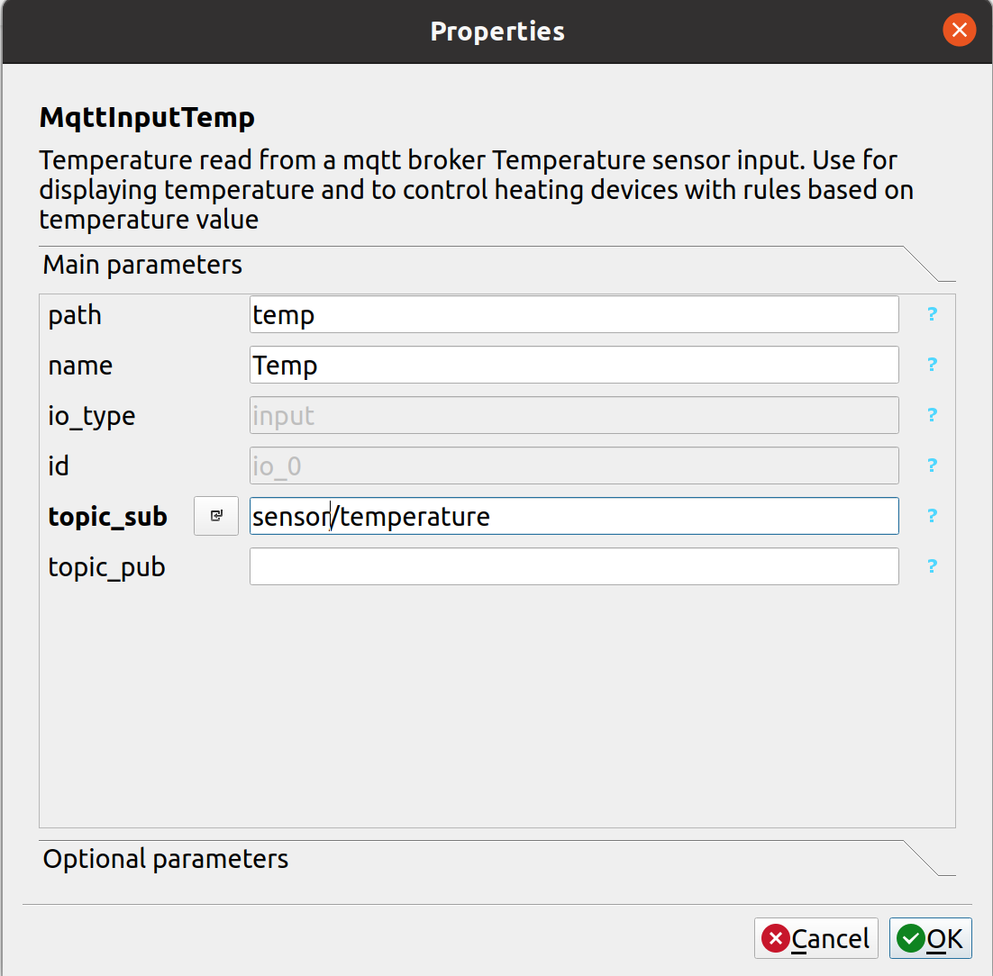
The value put into path is what is used to extract the message from the json. In the case of arrays of values this will differ. 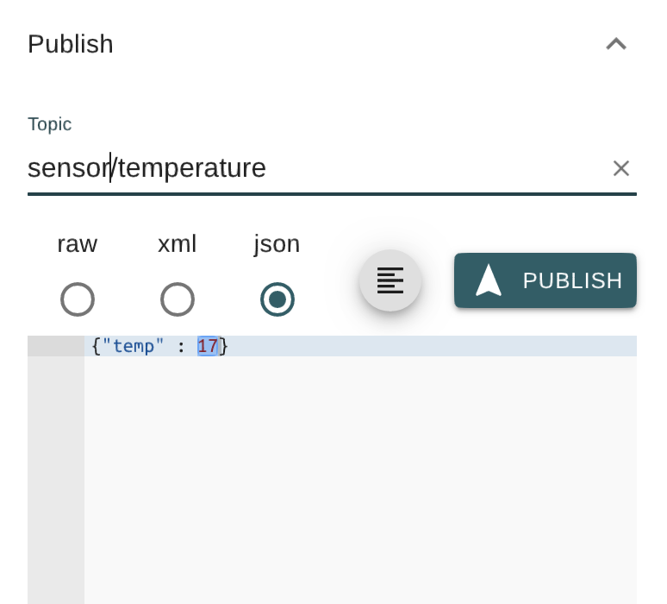
Note Topic names must be matched exactly. /sensor/temperature and sensor/temperature are separate topics

